# Responsibility assignment

1. *The constraint is enforced in the use case:* ***II.1.3 Sign-Up.***
2. *The constraint is enforced in the diagram:*

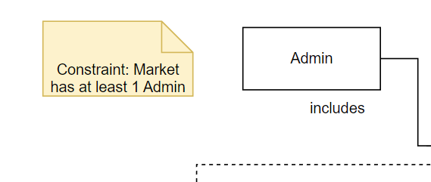

1. *The constraint is enforced in the diagram:*

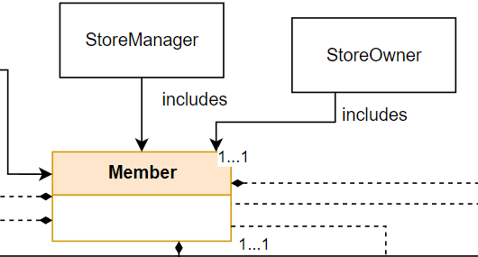

1. *The constraint is enforced in the use case:* ***II.1.1 Enter as a guest.***
2. *The constraint is enforced in the diagram:*

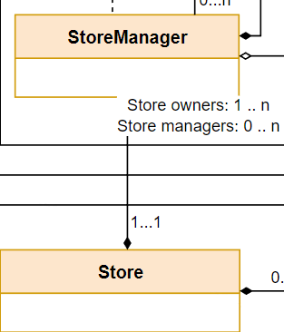

1. *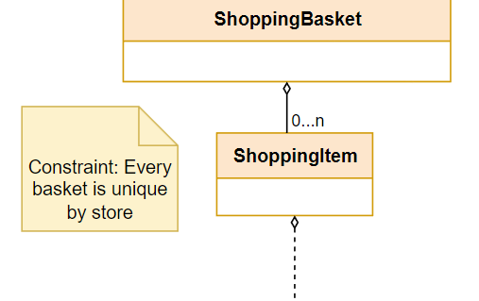The constraint is enforced in the diagram:*
2. *The constraint is enforced in the diagram:*

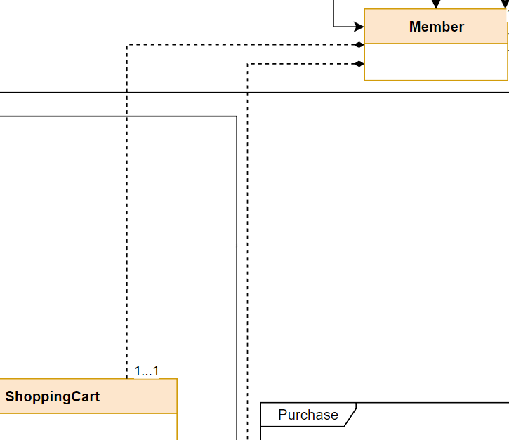

1. *The constraint is enforced in the use case:* ***II.2.5 Purchase a shopping cart.***
2. *The constraint is enforced in the use case:* ***II.2.5 Purchase a shopping cart.***
3. *The constraint is enforced in the diagram:**